# Tutorial 8A

Cluster Analysis

**Min cluster:**

Regression and Classification

**Knn :**

**Svc:**

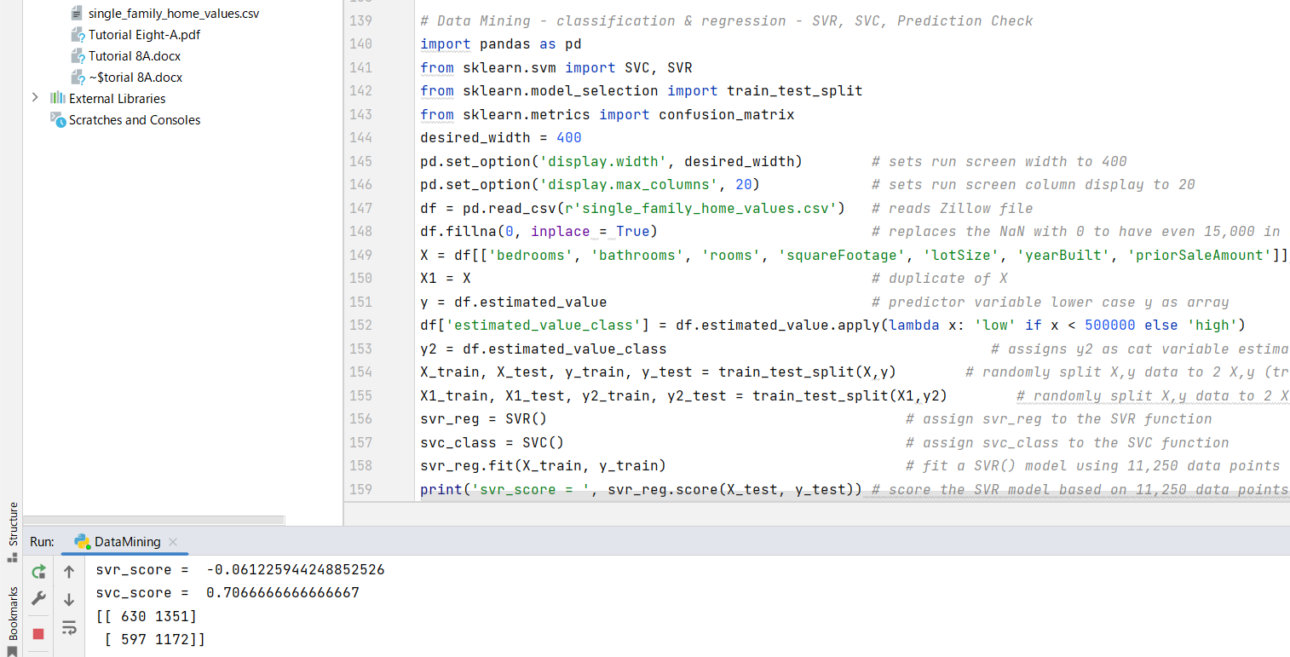

**Prediction check:**

**Association and Correlation**

**Dimensionality Reduction**

